* **What is Matrix ?**

**Definition:**

* A rectangular array of numbers is called a matrix. We shall mostly be concerned with matrices having real numbers as entries. The horizontal arrays of a matrix are called its rows and the vertical arrays are called its columns. A matrix having m rows and n columns is said to have the order m× n. A matrix A of order m× n can be represented in the following form:

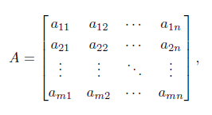

* Where a11is the entry at the intersection of the ith row and jth

column.

* In a more concise manner, we also denote the matrix A by [aij] by suppressing its order.

**Remark Some books also use,**

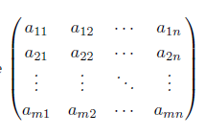

* A matrix having either a single row (m=1) or a single column (n=1) is defined to be a vector because it is often used to define the coordinates of a point in a multi-dimensional space. (In this note the convention has been adopted of representing a vector by a lower case “bold-face” letter such as **x**, and a general matrix by a “bold-face” upper case letter.

